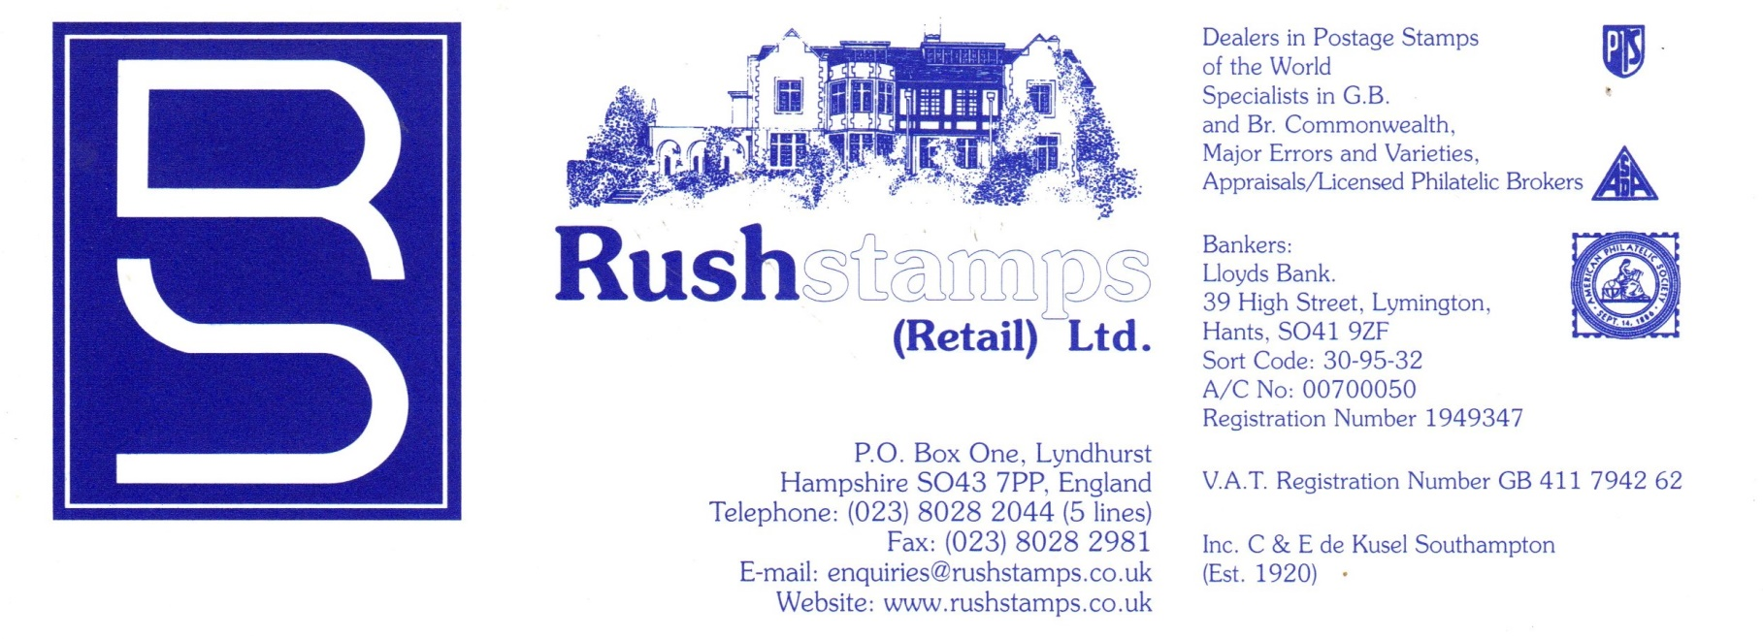

Updated 11/03/2020

G.B. MAJOR ERRORS & PHOSPHOR OMITTED LISTING
We have pleasure in enclosing our NEW G.B. Major Errors listing for your perusal – some real goodies and RARE items included – at REALISTIC NETT PRICES to tempt you ALONG WITH OUR Non-Phosphor Listing of G.B. Machins, Regionals and Commemoratives.!

All Subject Unsold. First Come First Served. In some cases we have more than one available.
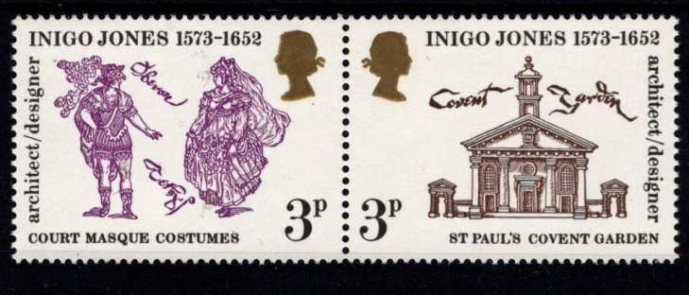
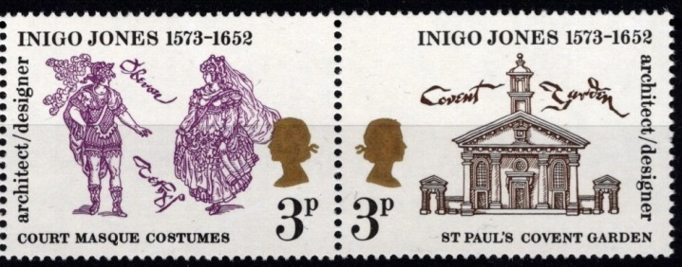

Normal Error
1973 Inigo Jones 3p pair, SG 935a with HUGE 10mm Queen’s Gold Head shift to just above the denomination with normal. Quite Exceptional…………………………………………………… £75.00
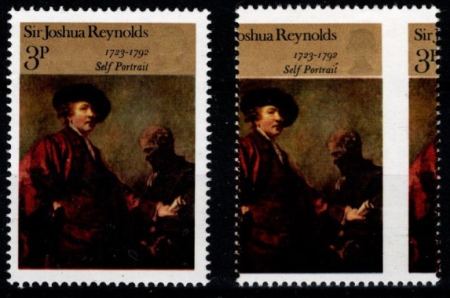
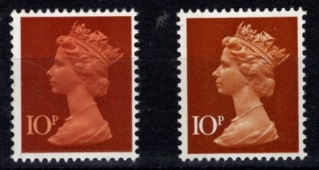

MACHIN 1971 10p
‘Orange Brown’ Omitted, causing
the denomination to be white
instead of Orange Brown
SG X885a (Cat. £200) £95.00

1973 PAINTINGS 3p
With MASSIVE VERTICAL
PERFORATION SHIFT –
QUITE FANTASTIC £35.00

(Enquiries for Side Marginal Pairs Invited!)
REMEMBER WE OFFER ‘INTEREST FREE’ EXTENDED PAYMENT FACILITIES
OVER 3 MONTHS. RESERVE YOUR CHOICE(S) TODAY!

U/M INVERTED WATERMARKS
1964 Shakespeare 1/3 Phosphor 648pWi £400.00 £295.00
1964 Geographical 8d 653Wi £2200.00 £1050.00
1964 Geographical 1/6 654Wi £55.00 £25.00
1964 Botanical 9d 657Wi £75.00 £27.50
1965 Parliament 2/6 664Wi £60.00 £20.00
1965 Battle of Britain 9d 677Wi £100.00 £60.00
1966 Landscapes 1/6 692Wi £22.00 £10.00
1966 Battle of Hastings 1/3 Phosphor 712pWi £50.00 £30.00
1966 Christmas 1/6 714Wi £30.00 £12.00

